Registering Expiration Date

Current implementation for deposit registered individually:

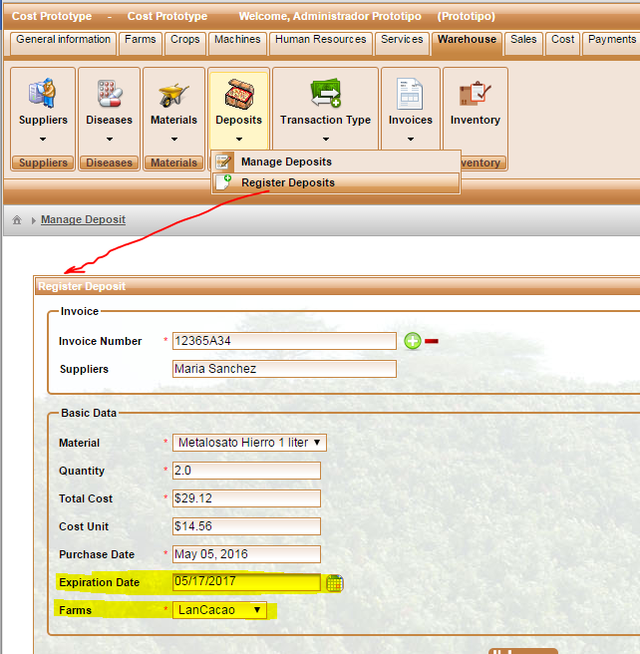

Values for these two fields are entered by user and both have to be required field. **\***

Similarly, when converting from invoice, Expiration Date needs to be required too.

